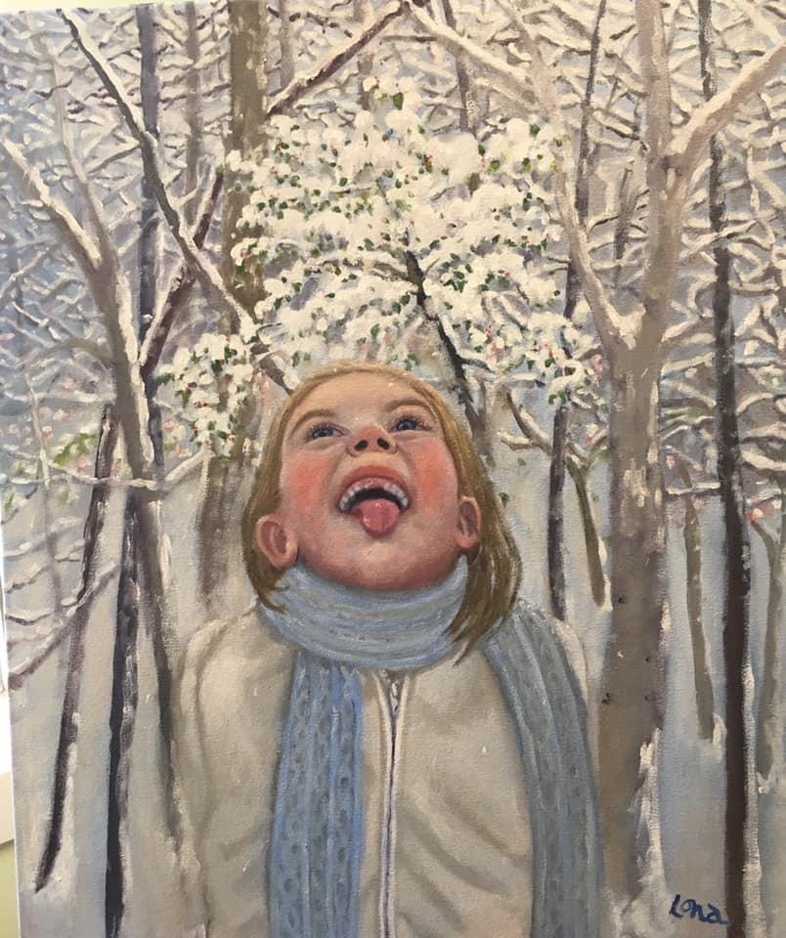
January 2020
Welcome to 2020. This calendar is composed of my seasonal series of paintings that I made of my beautiful granddaughters. -Lona

I painted this background from my studio window during an actual snow storm, then got a granddaughter to pose for the figure.
Sunday | Monday | Tuesday | Wednesday | Thursday | Friday | Saturday
 |  |  | 1 | 2 | 3 | 4
5 | 6 | 7 | 8 | 9 | 10 | 11
12 | 13 | 14 | 15 | 16 | 17 | 18
19 | 20 | 21 | 22 | 23 | 24 | 25
26 | 27 | 28 | 29 | 30 | 31

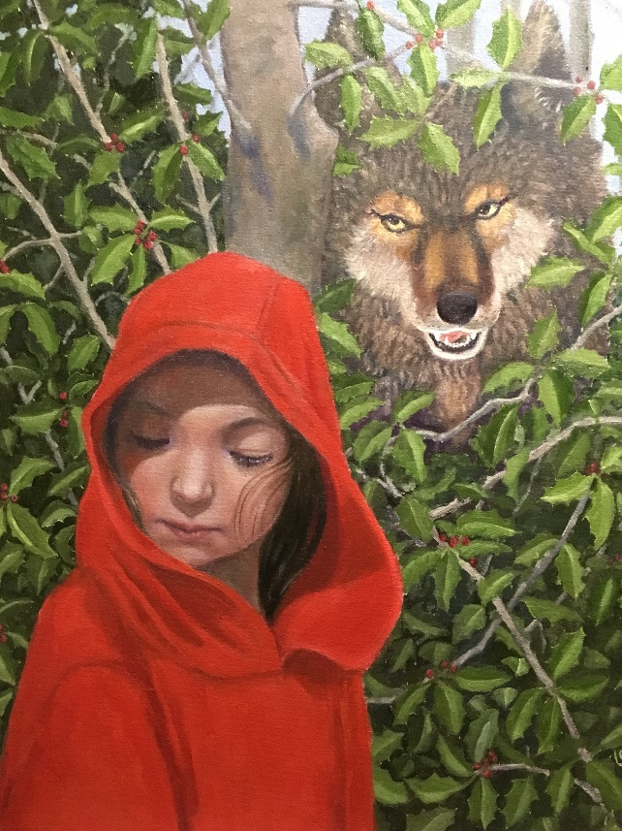
February 2020
This granddaughter found a red hoodie in a ‘lost and found’ and subsequently was seldom seen without it, which prompted me to paint her as Little Red Riding Hood.
Sunday | Monday | Tuesday | Wednesday | Thursday | Friday | Saturday
 |  |  |  |  |  | 1
2 | 3 | 4 | 5 | 6 | 7 | 8
9 | 10 | 11 | 12 | 13 | 14 | 15
16 | 17 | 18 | 19 | 20 | 21 | 22
23 | 24 | 25 | 26 | 27 | 28 | 29
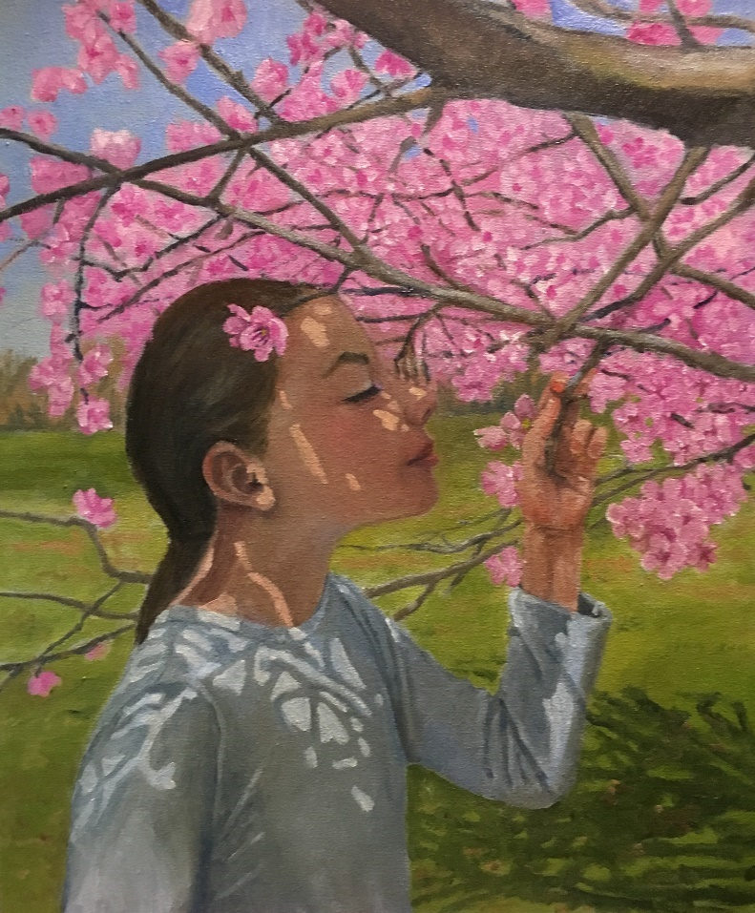
March 2020
I wanted to appreciate the beauty of the cherry blossoms, but then threw in a granddaughter too.

Sunday | Monday | Tuesday | Wednesday | Thursday | Friday | Saturday
1 | 2 | 3 | 4 | 5 | 6 | 7
8 | 9 | 10 | 11 | 12 | 13 | 14
15 | 16 | 17 | 18 | 19 | 20 | 21
22 | 23 | 24 | 25 | 26 | 27 | 28
29 | 30 | 31

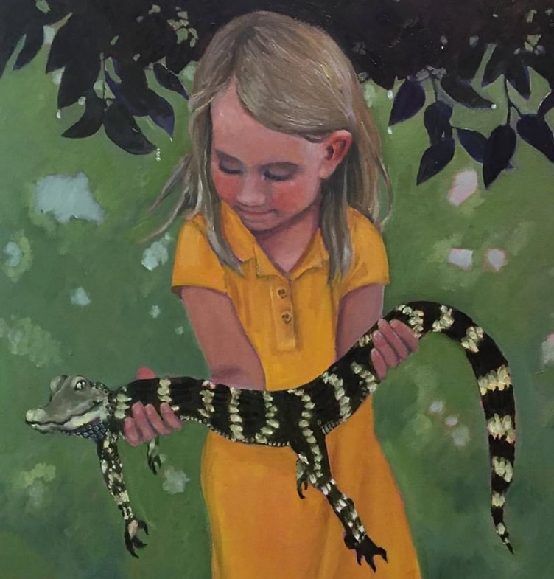
April 2020
I used artistic license to remove the tape that was holding the aligator’s jaws shut.
Sunday | Monday | Tuesday | Wednesday | Thursday | Friday | Saturday
 |  |  | 1 | 2 | 3 | 4
5 | 6 | 7 | 8 | 9 | 10 | 11
12 | 13 | 14 | 15 | 16 | 17 | 18
19 | 20 | 21 | 22 | 23 | 24 | 25
26 | 27 | 28 | 29 | 30

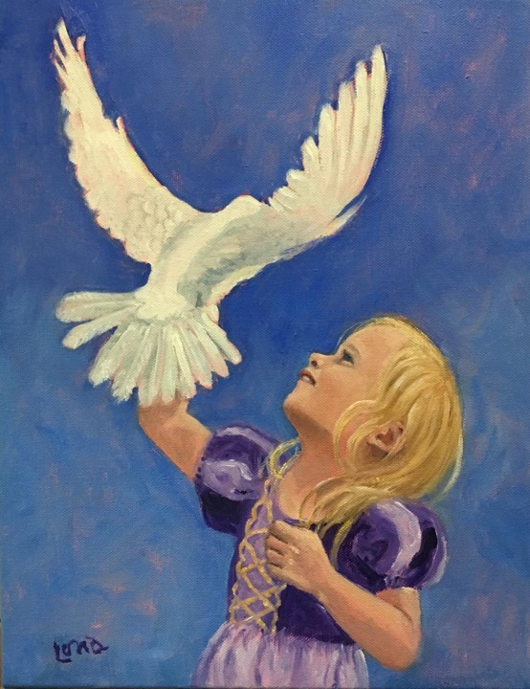
May 2020
This was inspired by a “Paint Peace” online event.
Birthday girl:
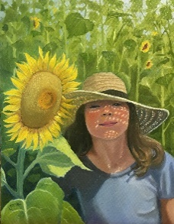
Sunday | Monday | Tuesday | Wednesday | Thursday | Friday | Saturday
 |  |  |  |  | 1 | 2
3 | 4 | 5 | 6 | 7 | 8 | 9
10 | 11 | 12 | 13 | 14 | 15 | 16
17 | 18 | 19 | 20 | 21 | 22 | 23
24/31 | 25 | 26 | 27 | 28 | 29 | 30
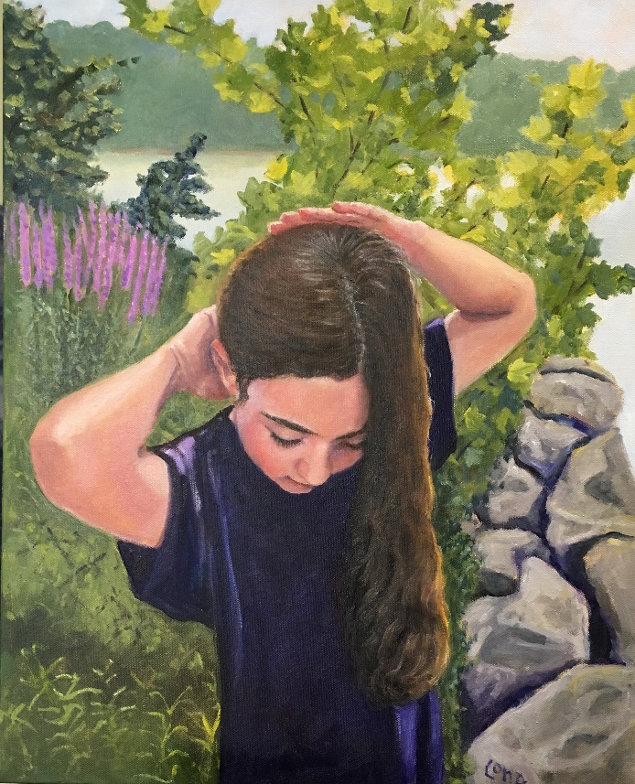
June 2020
Scene is Piscataway Park, on the shores of the Potomac River.
Birthday girl:
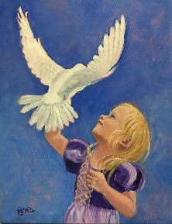
Sunday | Monday | Tuesday | Wednesday | Thursday | Friday | Saturday
 | 1 | 2 | 3 | 4 | 5 | 6
7 | 8 | 9 | 10 | 11 | 12 | 13
14 | 15 | 16 | 17 | 18 | 19 | 20
21 | 22 | 23 | 24 | 25 | 26 | 27
28 | 29 | 30

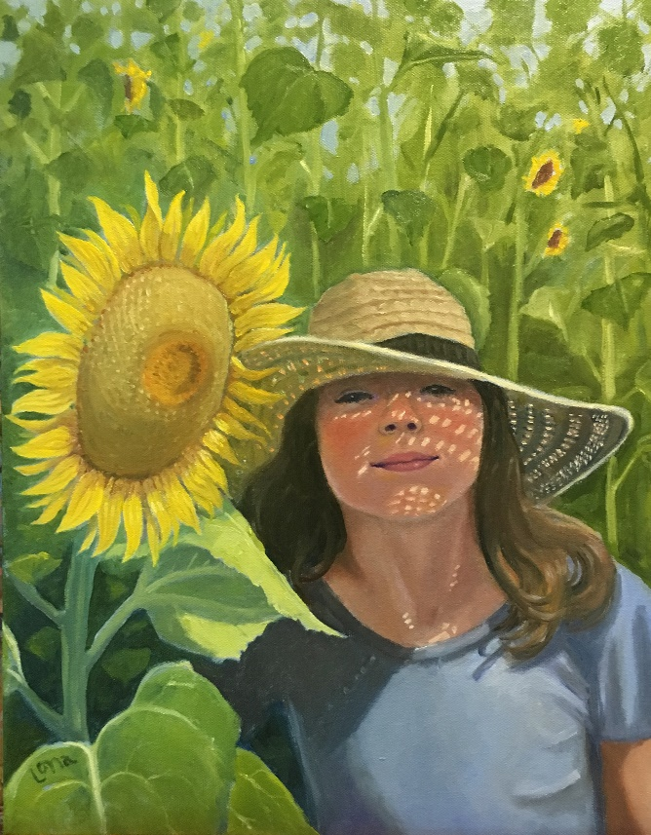
July 2020
Fun with the grandkids included a sunflower maze. I actually
got two paintings out of this experience.

Sunday | Monday | Tuesday | Wednesday | Thursday | Friday | Saturday
 |  |  | 1 | 2 | 3 | 4
5 | 6 | 7 | 8 | 9 | 10 | 11
12 | 13 | 14 | 15 | 16 | 17 | 18
19 | 20 | 21 | 22 | 23 | 24 | 25
26 | 27 | 28 | 29 | 30 | 31

August 2020
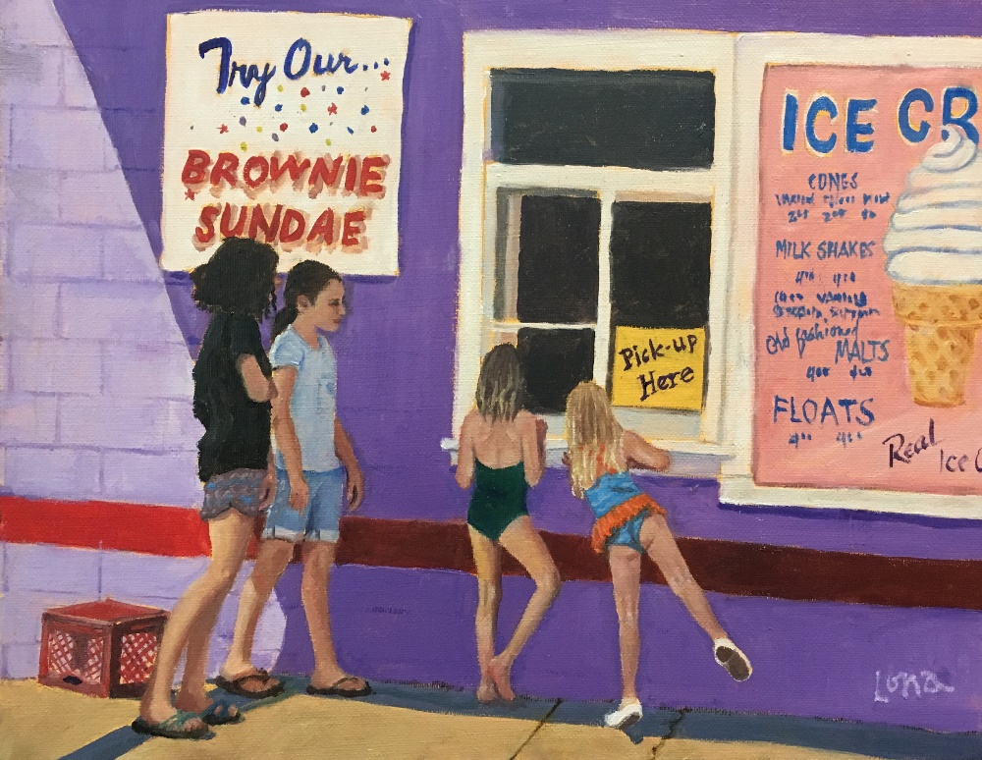
A painting of Accokeek’s B&Js Carryout where the grandkids know that they can get delicious treats.
Sunday | Monday | Tuesday | Wednesday | Thursday | Friday | Saturday
 |  |  |  |  |  | 1
2 | 3 | 4 | 5 | 6 | 7 | 8
9 | 10 | 11 | 12 | 13 | 14 | 15
16 | 17 | 18 | 19 | 20 | 21 | 22
23/30 | 24/31 | 25 | 26 | 27 | 28 | 29

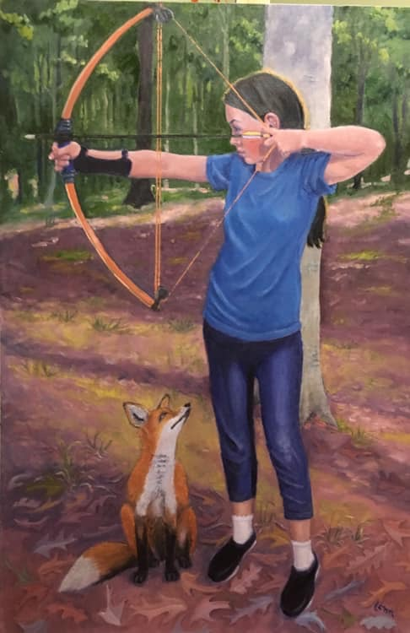
September 2020
Around the time I painted this I started adding animals to the paintings of the kids because they loved it.
Birthday girls:
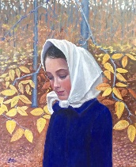
Sunday | Monday | Tuesday | Wednesday | Thursday | Friday | Saturday
 |  | 1 | 2 | 3 | 4 | 5
6 | 7 | 8 | 9 | 10 | 11 | 12
13 | 14 | 15 | 16 | 17 | 18 | 19
20 | 21 | 22 | 23 | 24 | 25 | 26
27 | 28 | 29 | 30
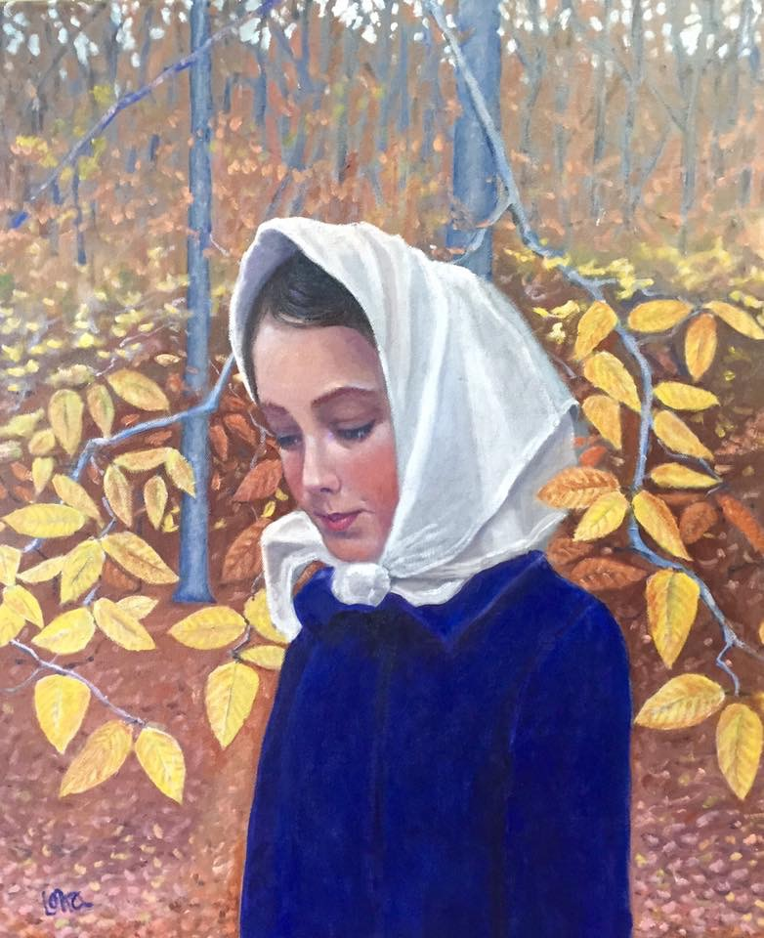
October 2020
This painting began my seasonal series.
Birthday girl:
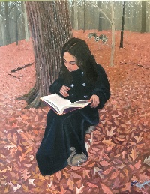
Sunday | Monday | Tuesday | Wednesday | Thursday | Friday | Saturday
 |  |  |  | 1 | 2 | 3
4 | 5 | 6 | 7 | 8 | 9 | 10
11 | 12 | 13 | 14 | 15 | 16 | 17
18 | 19 | 20 | 21 | 22 | 23 | 24
25 | 26 | 27 | 28 | 29 | 30 | 31

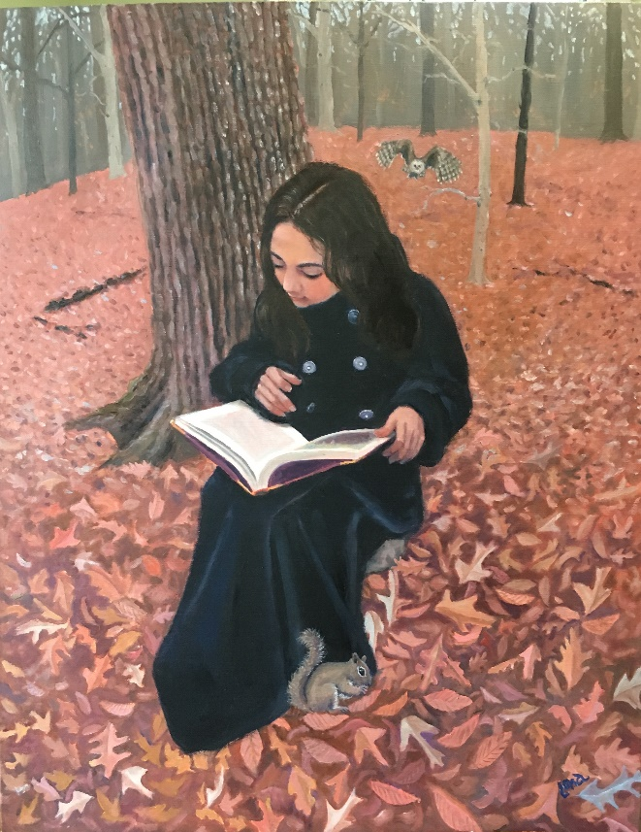
November 2020
This granddaughter was cooperative enough to pose in my black coat in the woods outside my house. She and her sister then insisted on the additions of the owl and squirrel.
Sunday | Monday | Tuesday | Wednesday | Thursday | Friday | Saturday
1 | 2 | 3 | 4 | 5 | 6 | 7
8 | 9 | 10 | 11 | 12 | 13 | 14
15 | 16 | 17 | 18 | 19 | 20 | 21
22 | 23 | 24 | 25 | 26 | 27 | 28
29 | 30

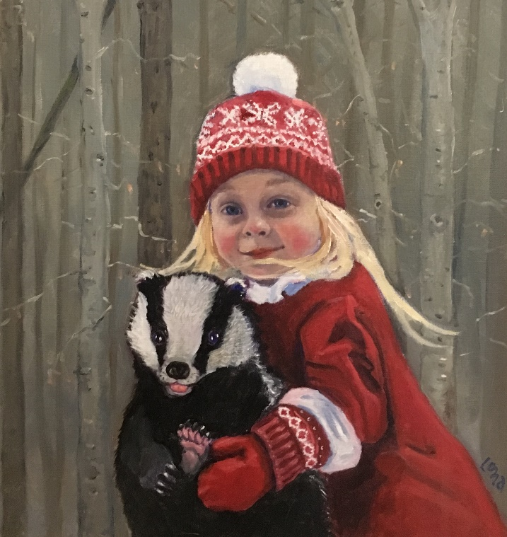
December 2020
This granddaughter loves to hug posts but I wanted her to be hugging something a little more interesting...
Sunday | Monday | Tuesday | Wednesday | Thursday | Friday | Saturday
 |  | 1 | 2 | 3 | 4 | 5
6 | 7 | 8 | 9 | 10 | 11 | 12
13 | 14 | 15 | 16 | 17 | 18 | 19
20 | 21 | 22 | 23 | 24 | 25 | 26
27 | 28 | 29 | 30 | 31

